1. Create one VPC in N.virginia region.

To create a VPC in the Mumbai region (ap-south-1), follow these steps:
- Open the AWS Management Console or use AWS CLI configured with the Mumbai region.
- Navigate to the VPC Dashboard.
- Click the "Create VPC" button.
- Enter the Name tag as "AnisVPC".
- Specify the CIDR block, for example, 10.0.0.0/16.
- Choose IPv4 CIDR block.
- Click "Create" to finalize the VPC creation.
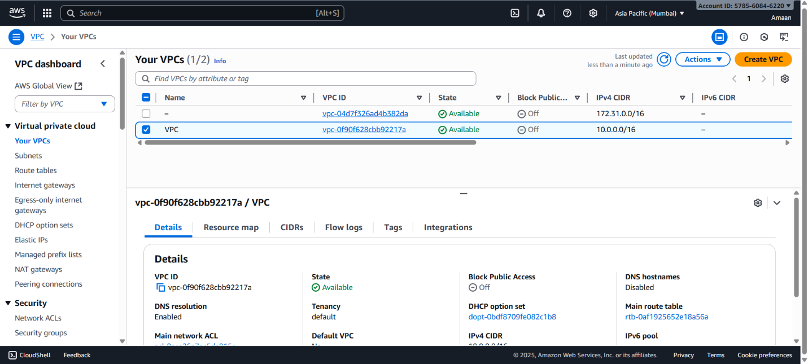

2. Create two subnets. One Public subnet and one private subnet.

To create two subnets in the VPC "AnisVPC" in the Mumbai region:
- In the VPC Dashboard, go to "Subnets" and click "Create Subnet."
- Select the VPC "AnisVPC."
For the Public Subnet:
3. Enter the Name tag as "AnisPublicSubnet."
4. Choose Availability Zone "ap-south-1a."
5. Set the CIDR block to 10.0.1.0/24.
6. Create the subnet.
For the Private Subnet:
7. Repeat the steps, entering Name tag as "AnisPrivateSubnet."
8. Choose Availability Zone "ap-south-1b."
9. Set the CIDR block to 10.0.2.0/24.
10. Create the subnet.
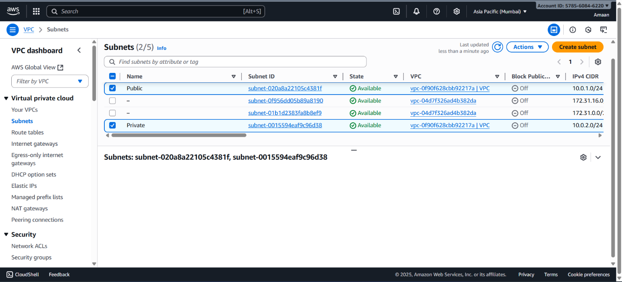

3. Provide the IGW to the vpc.

To provide an Internet Gateway (IGW) to the VPC "AnisVPC," follow these steps:
- Go to the VPC Dashboard and select "Internet Gateways."
- Click "Create Internet Gateway."
- Enter the Name tag as "AnisIGW."
- Click "Create Internet Gateway."
- Select the created Internet Gateway "AnisIGW."
- Click "Actions" and choose "Attach to VPC."
- Select the VPC "AnisVPC" and click "Attach."
This attaches the IGW to the VPC, enabling internet connectivity.
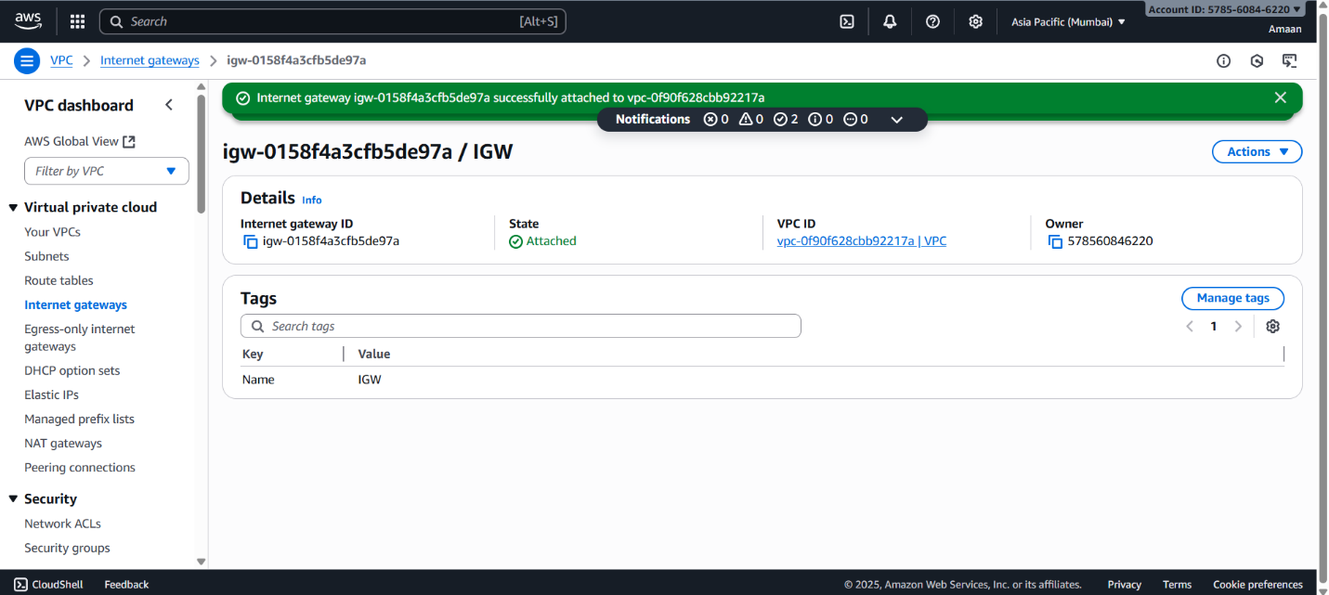

4. Create One public RT and one private RT.

To create one public route table and one private route table for the VPC "AnisVPC":
- In the VPC Dashboard, go to "Route Tables."
- Click "Create Route Table."
- Enter the Name tag as "AnisPublicRT."
- Select the VPC "AnisVPC."
- Click "Create" to create the public route table.
- Repeat the steps to create another route table.
- Enter the Name tag as "AnisPrivateRT."
- Select the VPC "AnisVPC."
- Click "Create" to create the private route table.
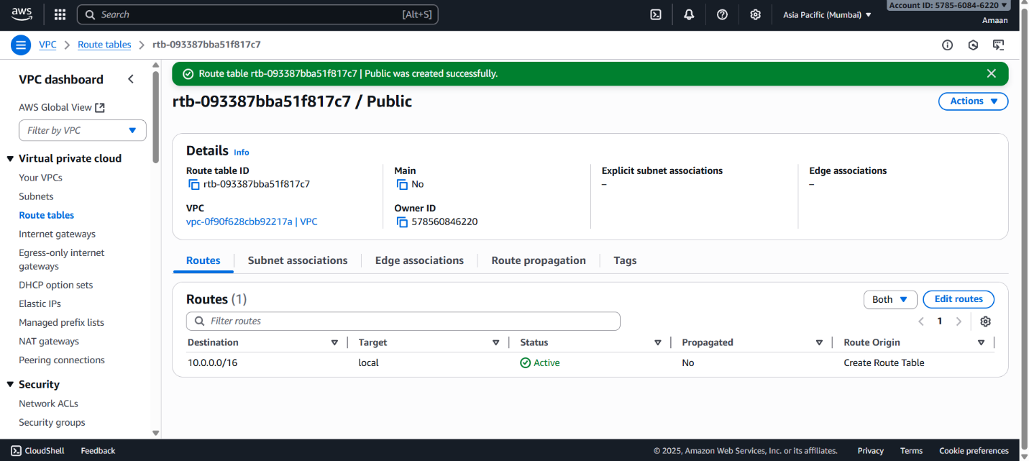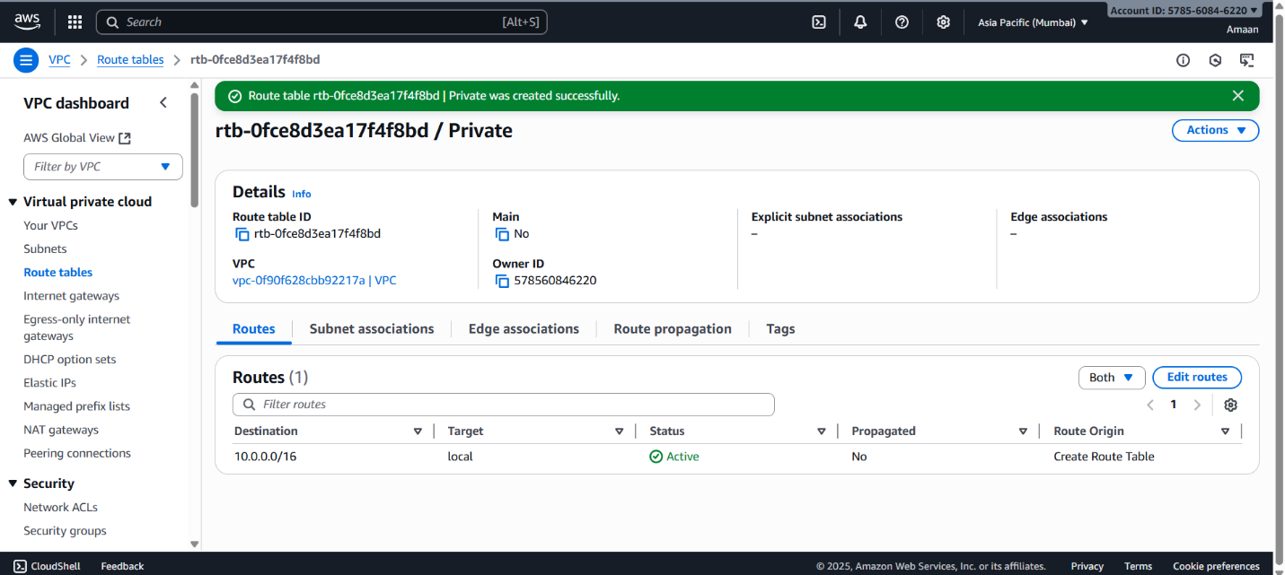

5. Deploy NAT gateway on public subnet and attach the NAT gateway to private
subnet.

To deploy a NAT Gateway on the public subnet "AnisPublicSubnet" and attach it to the private subnet in your VPC:
- Allocate an Elastic IP (EIP).
- Go to the VPC Dashboard and select "NAT Gateways."
- Click "Create NAT Gateway."
- Choose the subnet "AnisPublicSubnet" for the NAT Gateway.
- Assign the allocated Elastic IP to the NAT Gateway.
- Click "Create NAT Gateway."
Then, to route private subnet traffic through the NAT Gateway:
- Go to "Route Tables."
- Select the private route table "AnisPrivateRT."
- Click "Edit routes."
- Add a route with destination 0.0.0.0/0 and target as the NAT Gateway ID.
- Save the routes.
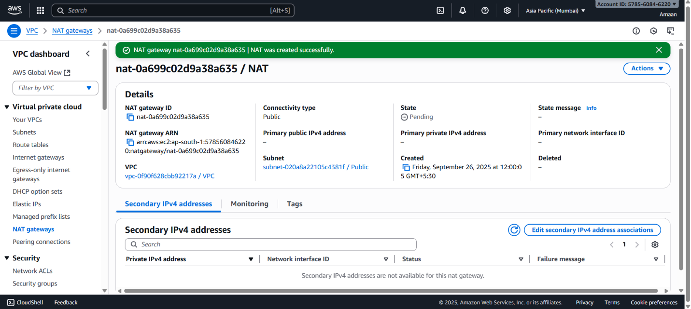
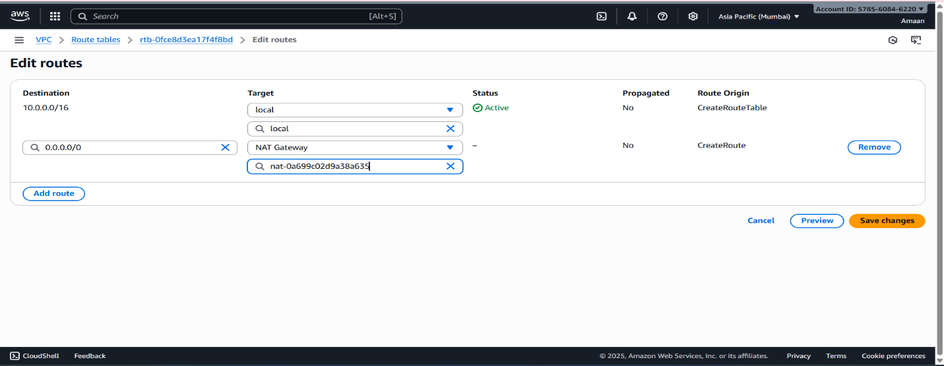
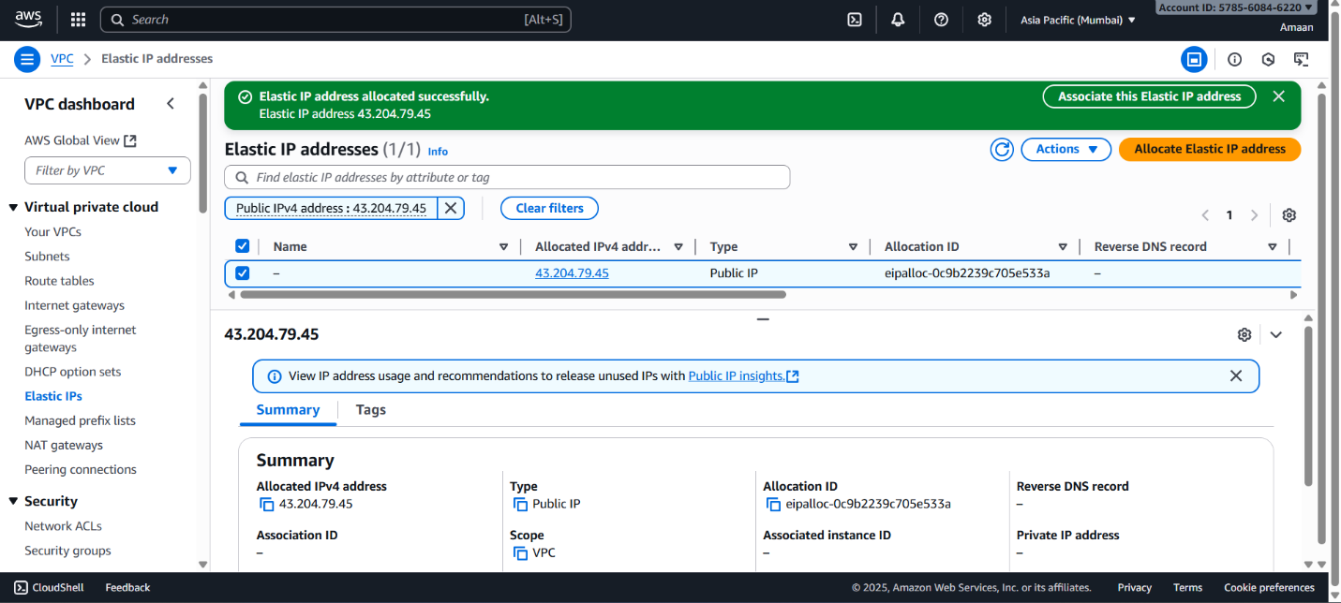

6. Create Two instances,one in public subnet and one in private subnet.

To create two EC2 instances, one in the public subnet and one in the private subnet of VPC "AnisVPC":
For the Public Instance:
- Name it "AnisPublicInstance."
- Choose an AMI such as Amazon Linux 2.
- Select an instance type like t2.micro.
- Configure network settings: select VPC "AnisVPC" and subnet "AnisPublicSubnet."
- Enable auto-assign public IP.
- Configure security group to allow SSH (port 22) and HTTP (port 80) from anywhere (0.0.0.0/0).
- Review settings and launch.
For the Private Instance:
- Name it "AnisPrivateInstance."
- Use the same AMI and instance type.
- Select VPC "AnisVPC" and subnet "AnisPrivateSubnet."
- Disable auto-assign public IP.
- Configure security group to allow SSH access only from the public subnet or specific IP addresses.
- Review and launch.
This completes the setup of one instance in the public subnet and one in the private subnet for your VPC.
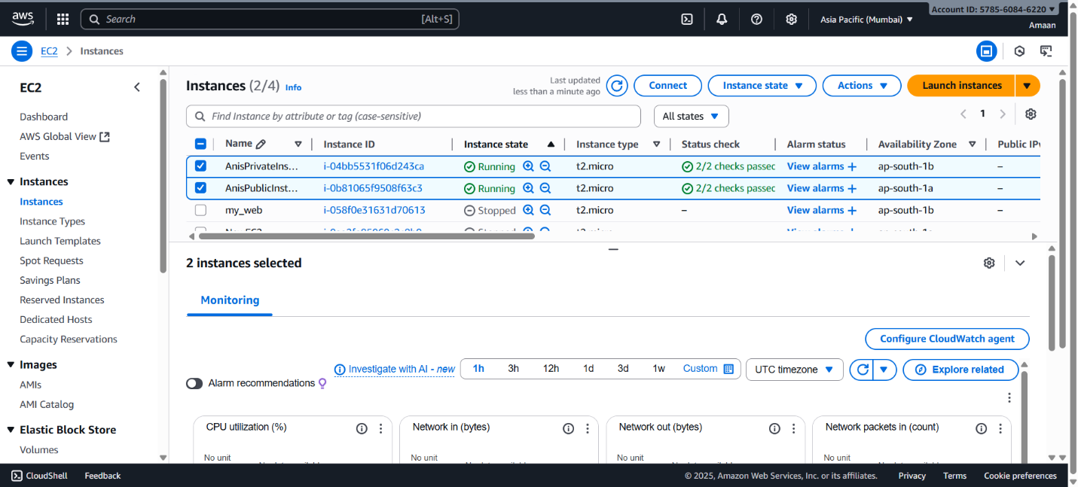

7. Deploy Apache server on both the ec2 instances with sample index.html file.

To deploy Apache server on both EC2 instances (public and private) and host a sample index.html file, follow these steps:
For Both Instances:
- Connect to the EC2 instance via SSH.
  - For the public instance, use its public IP.
  - For the private instance, connect through the public instance (bastion host) or VPN.
- Update the package repository:
text
sudo yum update -y
- Install Apache web server:
text
sudo yum install httpd -y
- Start the Apache service and enable it to run on boot:
text
sudo systemctl start httpd
sudo systemctl enable httpd
To Deploy Sample index.html:
- Create or edit the index.html file on the Apache default web location:
text
echo "<html><body><h1>Welcome to Anis Apache Server</h1></body></html>" | sudo tee /var/www/html/index.html
- Ensure AWS Security Group for the public instance allows HTTP (port 80) access from anywhere.
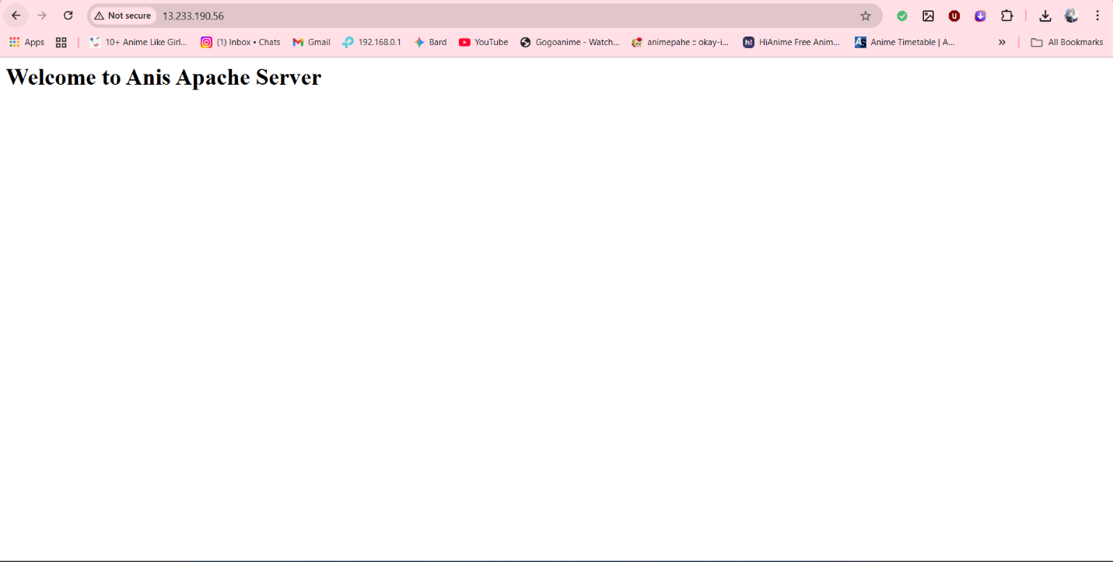

Now, accessing the public instance’s public IP address via a browser should display the sample webpage. For the private instance, you can access the webpage internally or via VPN/bastion host.
This completes Apache deployment and sample webpage setup on both EC2 instances.
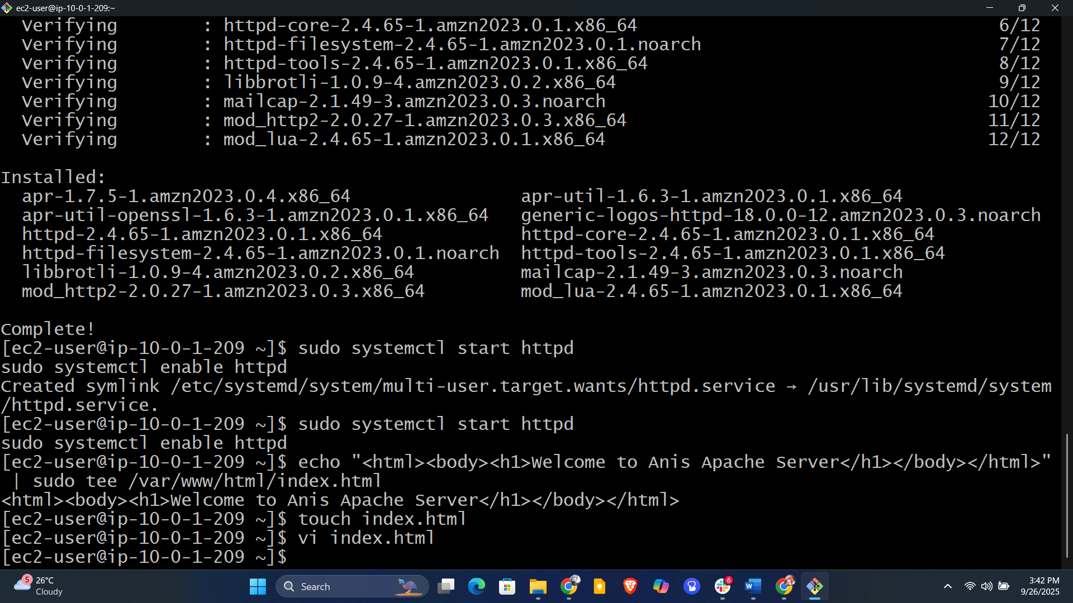
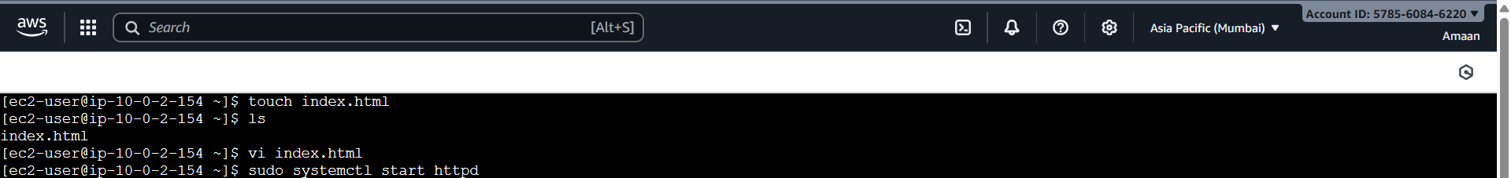
8. Create one application load balancer and attach the load balancer to both the ec2
instances.
Here are the clear steps to create an Application Load Balancer (ALB) and attach both EC2 instances ("AnisPublicInstance" and "AnisPrivateInstance") to it:
Step 1: Create Target Group
- Go to the AWS Management Console.
- Navigate to EC2 → Target Groups.
- Click "Create target group."
- Choose "Instances" as the target type.
- Enter a name, e.g., "AnisTargetGroup."
- Choose protocol: HTTP and port: 80.
- Select the VPC where your instances are located.
- Click "Next."
- Select both instances (AnisPublicInstance and AnisPrivateInstance).
- Click "Include as pending below."
- Click "Create target group."
Step 2: Create Application Load Balancer
- Navigate to EC2 → Load Balancers.
- Click "Create Load Balancer" → "Application Load Balancer."
- Enter a name for your ALB, e.g., "AnisALB."
- Scheme: internet-facing (to make it accessible from the internet).
- IP address type: ipv4.
- Under Listeners, keep Protocol HTTP and Port 80.
- Under Availability Zones, select the VPC and the public subnets (at least two).
- Click "Next."
Step 3: Configure Security Settings
- Skip for HTTP (unless using HTTPS).
Step 4: Configure Security Groups
- Select or create a security group allowing inbound HTTP (port 80) from 0.0.0.0/0.
Step 5: Configure Routing
- Select the target group "AnisTargetGroup" created in Step 1.
- Click "Next."
Step 6: Review and Create
- Review your setup.
- Click "Create."
Step 7: Test Load Balancer
- Once created, get the DNS name of the ALB from the console.
- Access it via a browser and it should distribute traffic to both EC2 instances on port 80.
This ALB will distribute incoming HTTP requests to both your public and private instances evenly.
Let me know if you want details on configuring HTTPS or health checks!
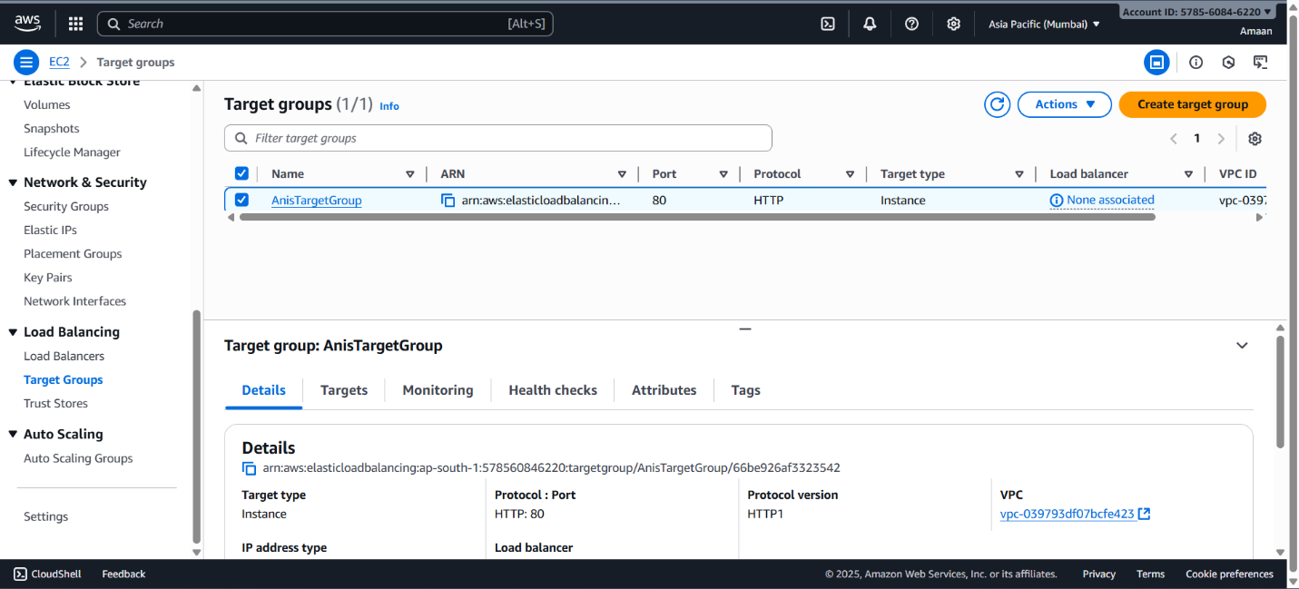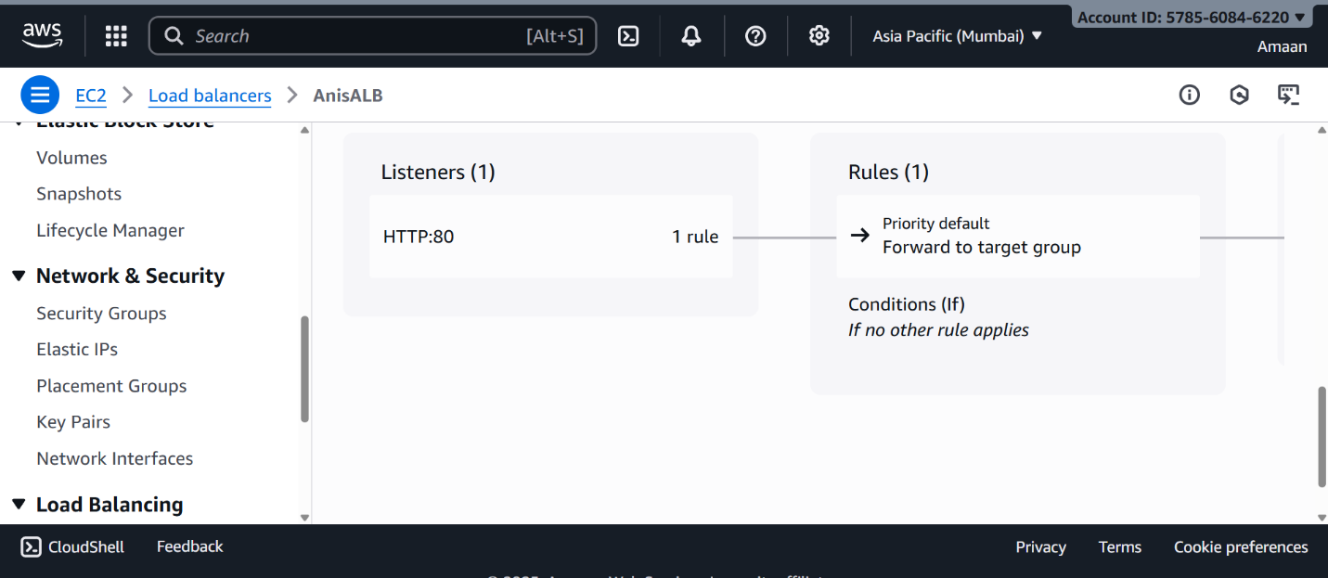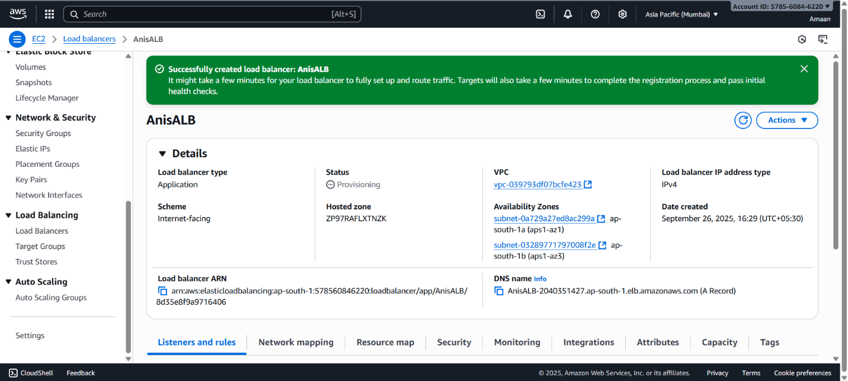
9. Store Application load balancer logs to s3.

To store Application Load Balancer (ALB) logs in an S3 bucket, follow these steps:
Step 1: Create an S3 Bucket for ALB Logs
- Open the AWS Management Console.
- Navigate to S3.
- Click "Create bucket."
- Enter a unique bucket name, such as "anis-alb-logs-<unique-suffix>".
- Select the AWS region (preferably same region as your ALB).
- Configure bucket settings as needed (versioning, encryption can be enabled as desired).
- Click "Create bucket."
Step 2: Enable Access Logging on the ALB
- Go to the EC2 Console → Load Balancers.
- Select your Application Load Balancer (e.g., "AnisALB").
- Scroll down to the “Attributes” section.
- Click “Edit attributes.”
- Turn on "Access logs."
- For "S3 location," enter your S3 bucket name (e.g., "anis-alb-logs-<unique-suffix>").
- (Optional) Specify a prefix folder inside the bucket for better organization (e.g., "alb-logs/").
- Save the settings.
Step 3: Set Bucket Policy for ELB Logging
- Go to S3 Console.
- Select the bucket used for logs.
- Go to the "Permissions" tab → "Bucket Policy."
- Add the following bucket policy to allow AWS ELB to write logs:
json
{
"Version": "2012-10-17",
"Statement": [
{
"Sid": "AWSLoadBalancerLogsPolicy",
"Effect": "Allow",
"Principal": {
"Service": "logdelivery.elasticloadbalancing.amazonaws.com"
},
"Action": "s3:PutObject",
"Resource": "arn:aws:s3:::your-bucket-name/*",
"Condition": {
"StringEquals": {
"s3:x-amz-acl": "bucket-owner-full-control"
}
}
}
]
}
Replace "your-bucket-name" with your actual bucket name.
Step 4: Verify Logs
- After traffic starts flowing, logs will appear in the specified S3 bucket under the chosen prefix path.
This procedure enables efficient storage and analysis of ALB access logs in S3.

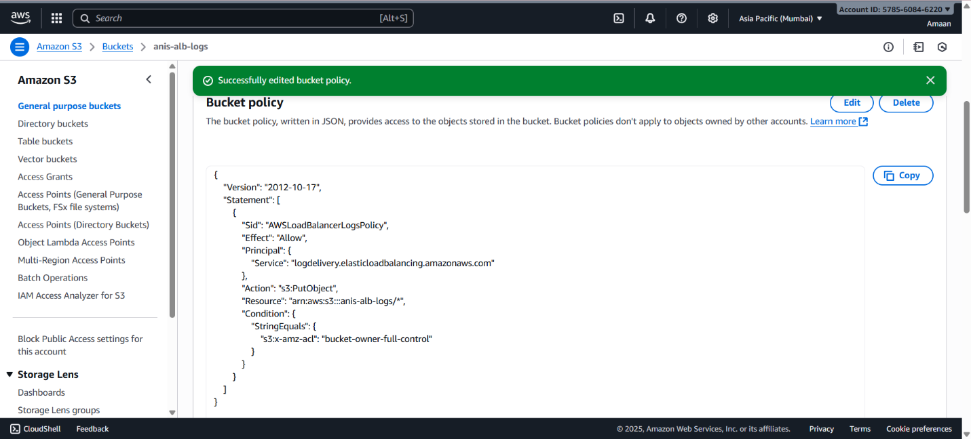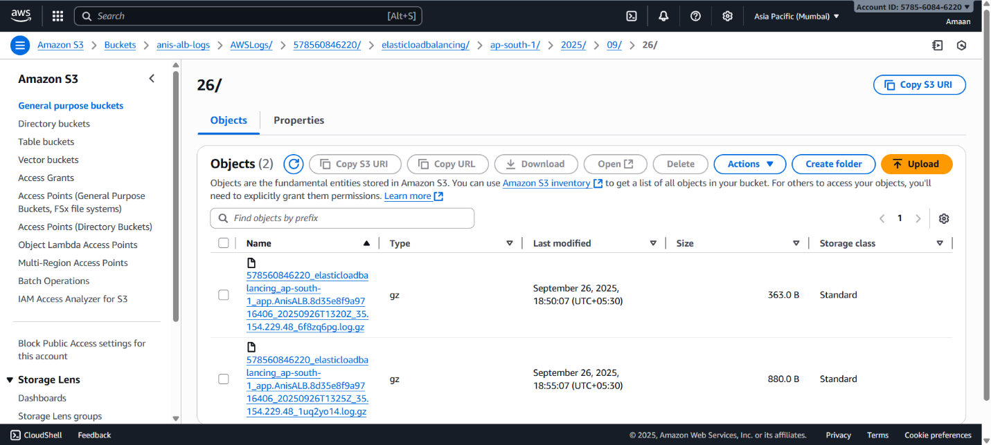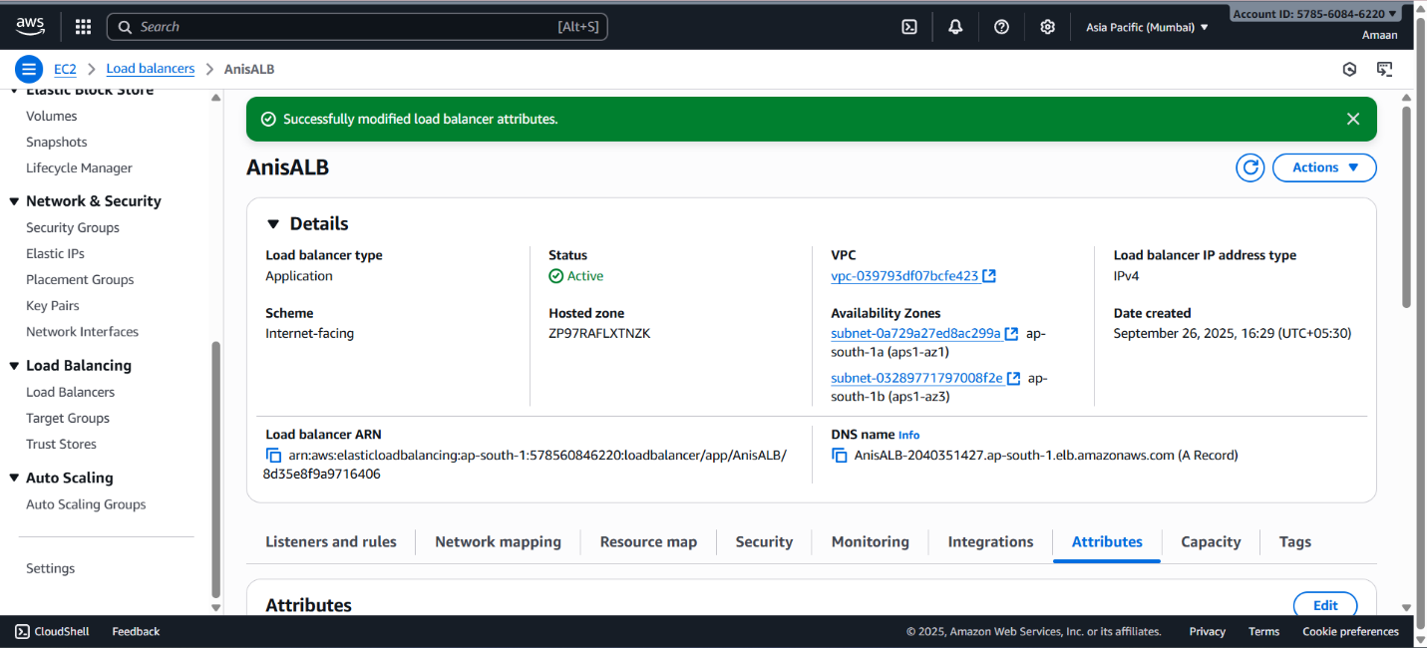
10. Store the VPC flow logs to CloudWatch group.

To store VPC Flow Logs to a CloudWatch Logs group, follow these steps:
Step 1: Create CloudWatch Log Group (if not existing)
- Open AWS Management Console.
- Navigate to CloudWatch → Logs → Log groups.
- Click "Create log group."
- Enter a name for the log group, e.g., /vpc/flow-logs.
- Configure retention period as desired.
- Click "Create."
Step 2: Create VPC Flow Logs
- Go to VPC Dashboard → Your VPCs.
- Select the VPC for which you want flow logs enabled (e.g., "AnisVPC").
- Click "Actions" → "Create flow log."
- Configure the flow log:
  - Filter: Choose All (to capture all traffic).
  - Destination: Choose "Send to CloudWatch Logs."
  - Log Group: Select the CloudWatch Log Group created (e.g., /vpc/flow-logs).
  - IAM Role: Select an existing IAM role with AWSLogs permissions or create a new one.
{To create a new IAM Role with the necessary permissions for VPC Flow Logs to send logs to CloudWatch, follow these steps:
Step 1: Create IAM Role
- Open the AWS Management Console.
- Navigate to IAM → Roles.
- Click "Create role."
- Select "AWS service" as the type of trusted entity.
- Choose the service "VPC" (or "EC2" if VPC is not listed).
- Click "Next: Permissions."
Step 2: Attach Policy
- Search for and select the managed policy named CloudWatchLogsFullAccess or AWSLogsFullAccess. This grants the role permission to write logs to CloudWatch.
- Click "Next: Tags" (optional to add tags).
- Click "Next: Review."
Step 3: Name and Create Role
- Give the role a descriptive name, e.g., VPCFlowLogsRole.
- Review and click "Create role."
Step 4: Use the Role in VPC Flow Logs
- When creating or editing your VPC flow log, select the role VPCFlowLogsRole under the IAM Role option.
This IAM role will allow the VPC flow logs to publish log data to CloudWatch Logs securely.
Let me know if you want me to generate the AWS CLI commands for this!To create a new IAM role with permissions for VPC Flow Logs to send logs to CloudWatch:
- Open AWS Console → IAM → Roles → Create role.
- Select AWS service as trusted entity, choose VPC or EC2 service.
- Attach the managed policy CloudWatchLogsFullAccess or AWSLogsFullAccess.
- Name the role e.g., VPCFlowLogsRole.
- Create the role.
- In VPC flow logs setup, select this role under IAM role.}
- Click "Create flow log."
Step 3: Verify Flow Logs
- Traffic logs from the VPC will start appearing in the selected CloudWatch Log Group.
This enables monitoring and analyzing network traffic at the VPC level using CloudWatch.
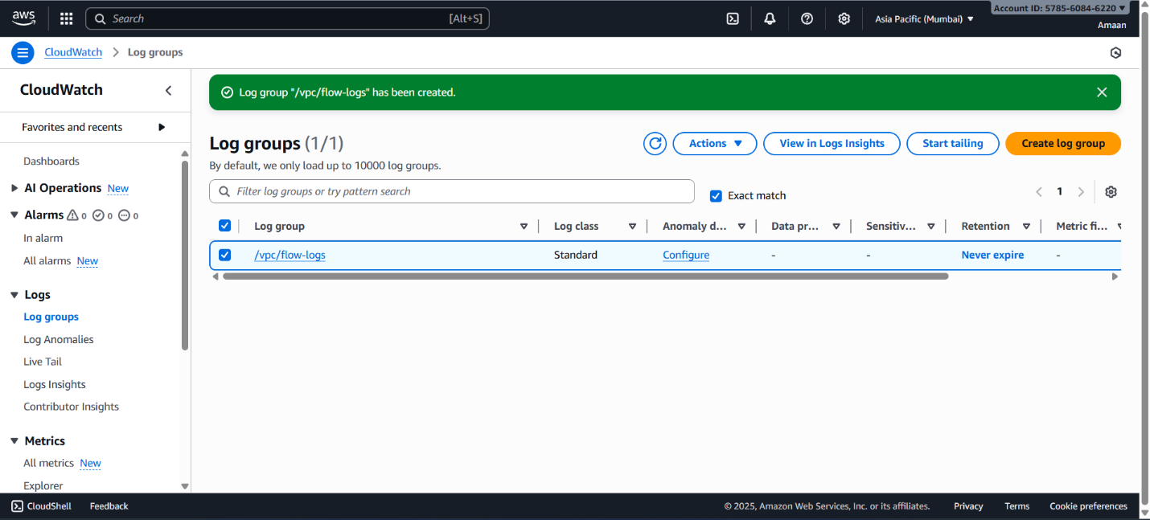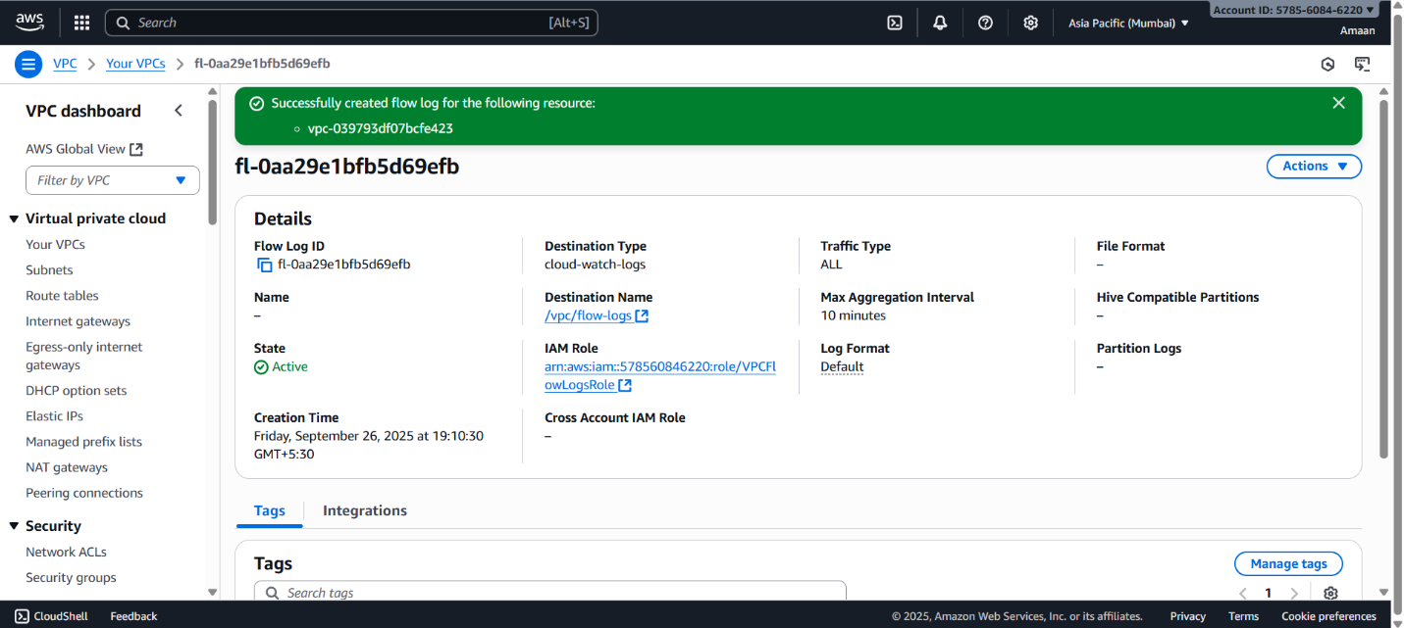
11. Create Monitoring Dashboards to monitor CPU utilization and to monitor Apache
service.

To create Monitoring Dashboards to monitor CPU utilization and Apache service, follow these steps:
Step 1: CPU Utilization Monitoring Dashboard
- Open AWS Console → CloudWatch → Dashboards.
- Click "Create dashboard", enter a name like "AnisAppDashboard".
- Add a widget:
  - Select "Line" widget.
  - Choose Metric.
  - Select "EC2" → "Per-Instance Metrics" → "CPUUtilization".
  - Select your EC2 instance(s).
- Configure widget title and period as desired.
- Save the widget on dashboard.
Step 2: Apache Service Monitoring (Using CloudWatch Agent)
- Install and configure CloudWatch Agent on your EC2 instances to collect Apache metrics (e.g., status codes, traffic).
- Create a config file to collect Apache logs or custom metrics:
  - For Apache log collection, specify log file path like /var/log/httpd/access_log.
  - For process status, monitor Apache service health via custom scripts or CloudWatch agent.
- Start the CloudWatch Agent to push Apache metrics to CloudWatch Logs/Custom Metrics.
Step 3: Add Apache Metrics to Dashboard
- In CloudWatch Dashboard, click Add widget.
- Select metric widget.
- Choose namespace where Apache custom metrics are pushed (e.g., "CWAgent").
- Select relevant Apache metrics like requests, error rates.
- Add widget and save dashboard.
Step 4: Set Alarms (Optional)
- You can create CloudWatch Alarms for CPU utilization threshold and Apache errors to get notified of issues.
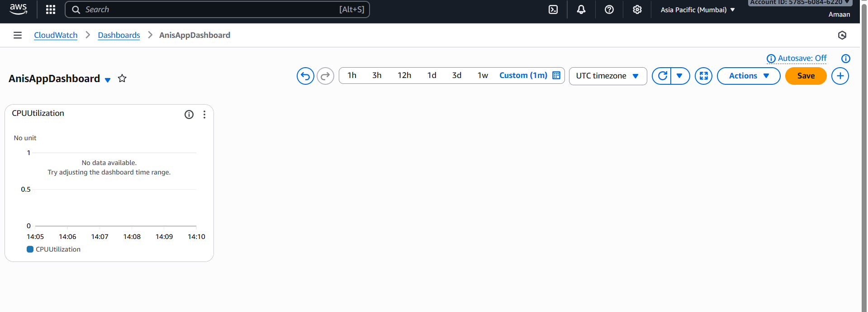
12. CPU utilizations more than 70% then it should triggered Autoscaling and launch
new instance.

To set up Auto Scaling triggered by CPU utilization exceeding 70% that launches a new instance, follow these steps:
Step 1: Create Launch Configuration or Launch Template
- Open AWS Management Console → EC2 → Launch Configurations (or Launch Templates).
- Create a new launch configuration/template using your current instance AMI and configuration.
- Specify instance type, key pair, security groups, and storage.
Step 2: Create Auto Scaling Group (ASG)
- Go to EC2 → Auto Scaling → Auto Scaling Groups.
- Click "Create Auto Scaling group."
- Choose the launch configuration/template created in Step 1.
- Specify the group name and select the VPC and subnets (public and private as desired).
- Set desired capacity, minimum size, and maximum size.
- Configure advanced options like load balancer (select your ALB).
Step 3: Create Scaling Policy
- Under the ASG settings, select "Add scaling policy."
- Choose "Target tracking policy" or "Step scaling policy."
- For target tracking:
  - Metric: EC2 CPU utilization.
  - Target value: 70%.
- For step scaling (optional):
  - Add alarm to monitor CPU utilization exceeding 70%.
  - Define scaling action: add 1 instance.
- Save policy.
Step 4: Verify Setup
- When CPU utilization across ASG instances crosses 70%, the policy triggers launch of new EC2 instance automatically.
This automatically scales your infrastructure based on CPU load.
